Q.1

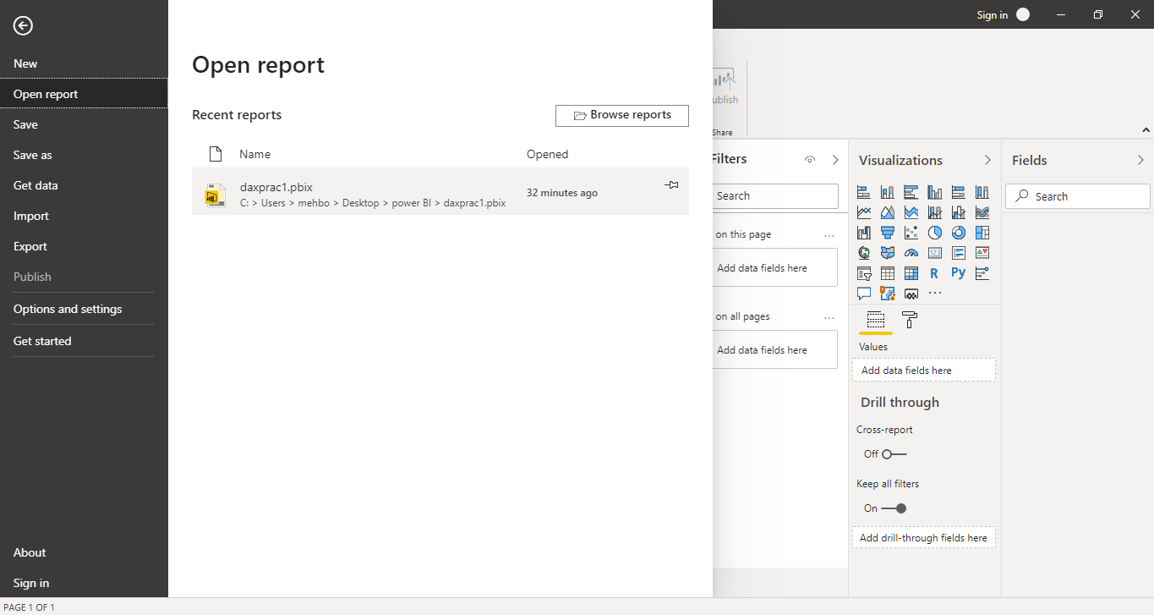

Q,2

Report view

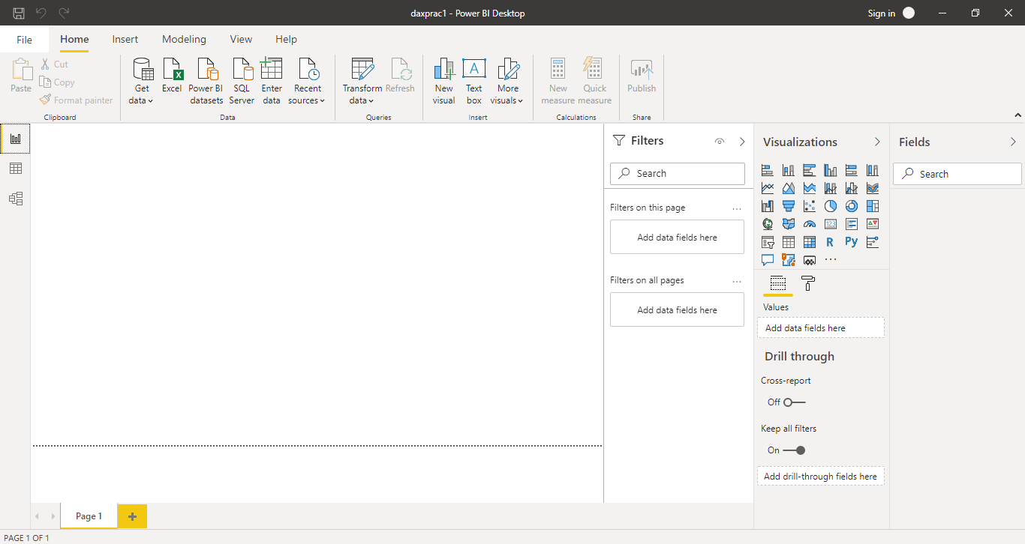

Data View

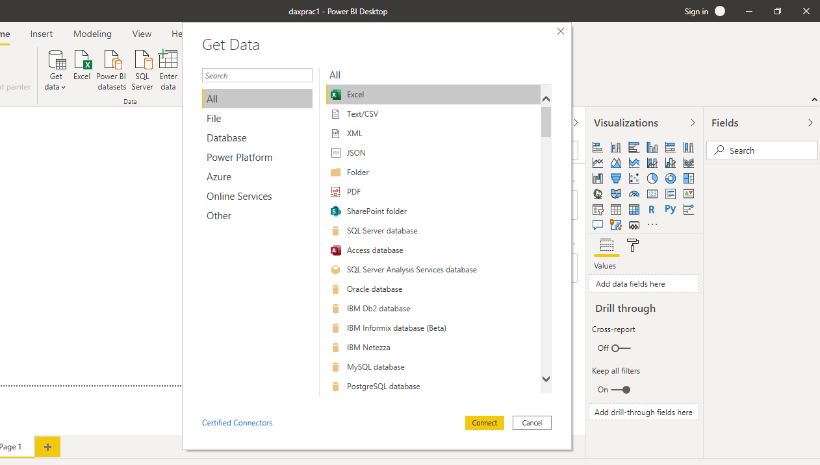

Model view

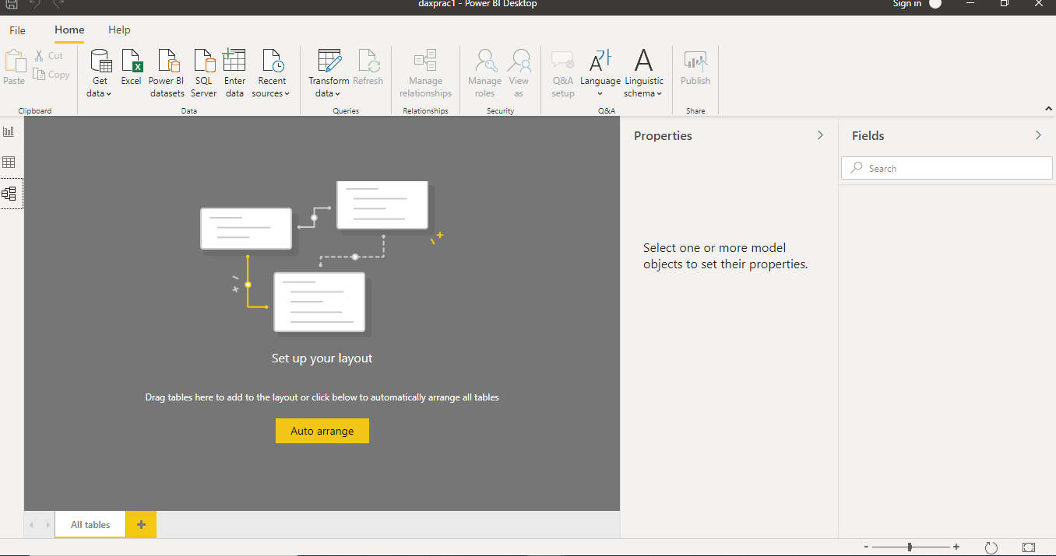

Power Query Editor

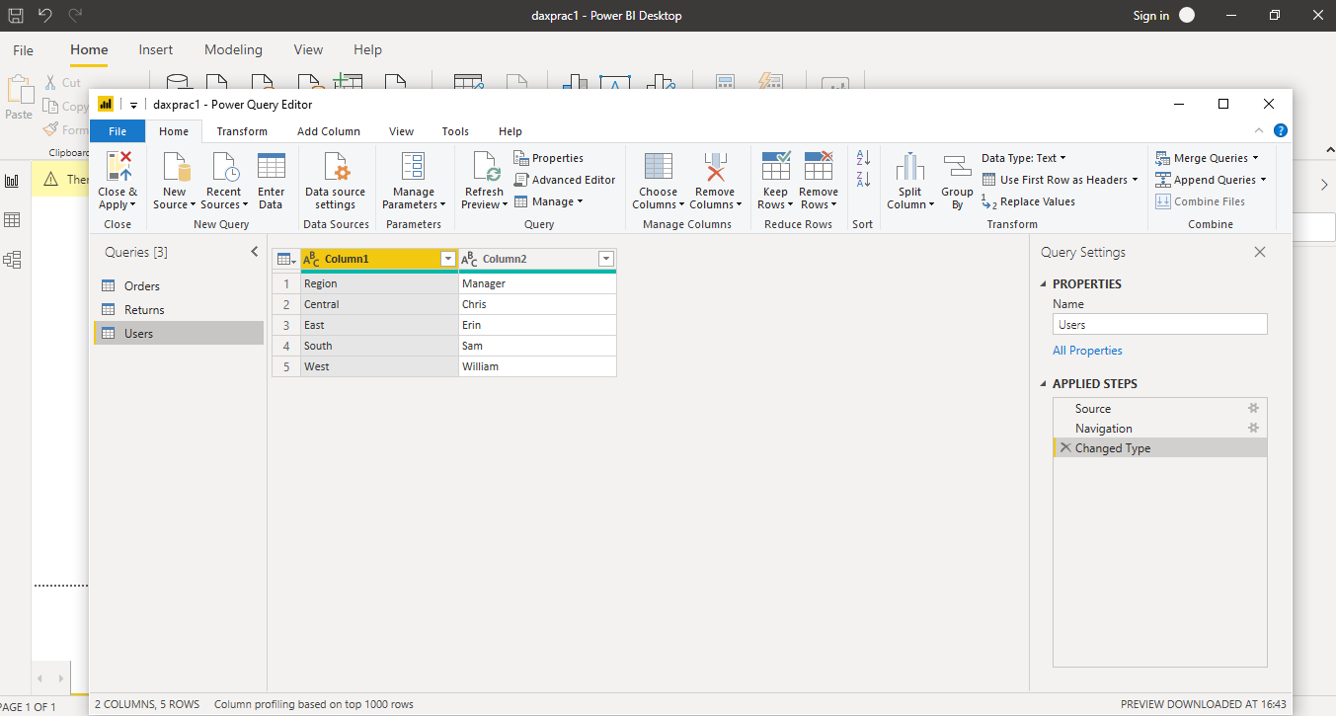

Advance editor

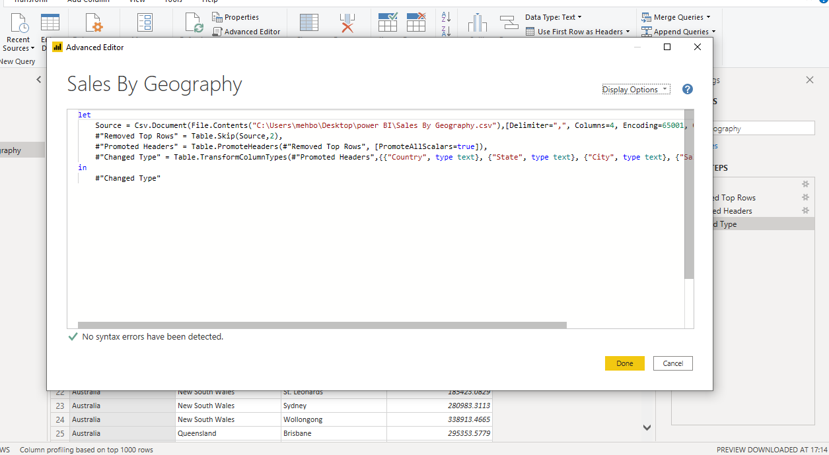

Q3

**Power BI** comes in three levels – Desktop, Pro, and Premium. The Desktop level **is** free for individual users, while the Pro plan **costs** $9.99 per user per month. The Premium plan starts at $4,995 a month per dedicated cloud compute and storage resource